**The Battle of Neighborhoods (Week 2)—**

**Private Property Sales Prices  
Data Analysis of Singapore**

**-- Su Yiping**

**Introduction:**

Singapore is recognised as the world’s safest country and it’s a playground for rich, only truly sovereign city-state does have a certain sheen of wealth in the world. Singapore is an island country with a high population density, over 5.6 million residents living in the land area of 725.7 km2,  (i.e. approximately 7870 people/ km2,).  The different areas and neighbourhoods can be divided into 28 districts. Every district has a very intertwined and mixed structure. It also can be divided the three regions in Singapore: Core Central Region (CCR), Outside Central Region (OCR) and Rest of Central Region (RCR).

In fact, Singapore is one of the easiest and most comfortable countries to navigate in Southeast Asia. It is a global hub for economy, finance, education, tourism, entertainment and healthcare, among many other areas.

If a group of stakeholders have a plan that is acquisition and sell of real estate for white collar. So, we need to analysis of various venues for finding useful insights into the kind of business thriving in difference locality.

**Objectives:**

This project aims at profiling the neighborhoods to come up with the best location for acquiring some real estates. The project of analysis will be based on the number and category of venues of various types present in Singapore.

Now let me explain more detail the context of this project through a scenario. Assume my company want to invest a real estate for residential, Every household want to have the great amenities that a lot of useful feature or facility of place exist in the neighborhood such as supermarket, shopping mall, gourmet fast food joints, cinema, park, pharmacies, graduate schools and so on. If everything around the real estates, maybe we need higher price acquiring, but if only some function in the neighborhood, maybe we need invest surrounding, otherwise we can’t get higher profit.

Through this project, we analyze the following things:

1. the top 10 commercial activities in each district
2. real estate sales price situation from 1975 to 2019
3. the unit price, area and total price of private property sales in each district from March 2017 to March 2020. etc.

**Python Tools:**

1. Using Panda package to create data frame and analyze the data
2. Using the BeautifulSoup package to scrape the following Wikipedia page,   [<https://en.wikipedia.org/wiki/Postal_codes_in_Singapore>,](https://en.wikipedia.org/wiki/List_of_postal_codes_of_Canada:_M) In order to obtain the data that is in the table of postal district (Postal sector: 1st 2 digits of 6-digit postal codes) and to transform the data
3. Using Geocoder package to get the latitude and the longitude coordinates of each neighborhood and create the new data frame.
4. Using Nominatim package for Open Street Map data
5. Using folium package to show the map
6. Using k-means package from hierarchical clustering algorithm sklearn.cluster to cluster the neighborhood
7. Using Numpy package for scientific computing.
8. Using deque package for store collections of data
9. Using tqdm package for nested loops
10. Using Axes3D package for created 3d visual graphics
11. Using seaborn package for making statistical graphics
12. Using random package for generating a random number
13. Using WordCloud package for making visual tags

**Data Frame:**

1. Scraped from website:

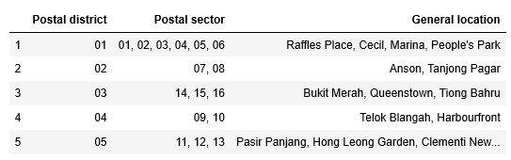

2. Add latitude and longitude of postal district to data frame 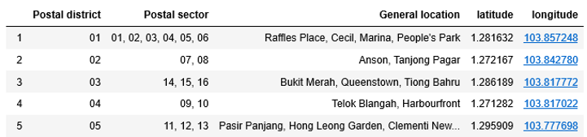

3. Top venue around the general location

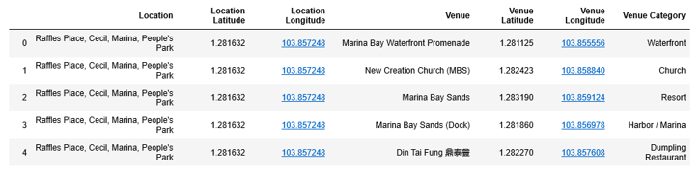

4. top 10 places of each general location

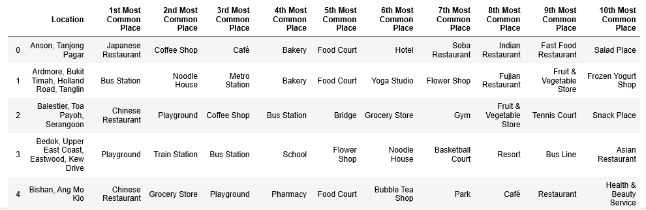

5. Private Residential Property Prices Data from 1975 1Q to 2019 4Q

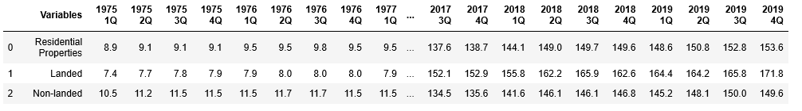

6. The private property sale data frame from multiple csv files

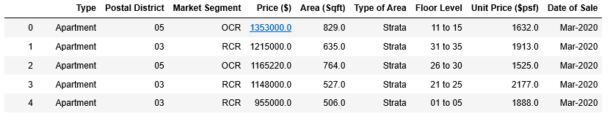

7. Data set process for Private Residential Property

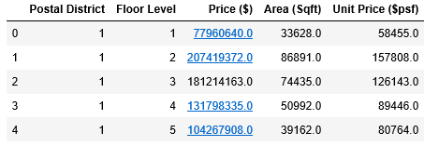

8. Basic statistical details for Private Residential Property

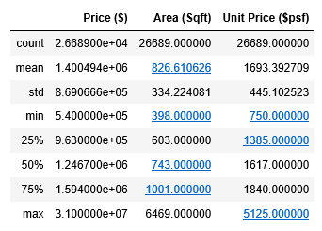

9. Summary group by selling date for Market Segment

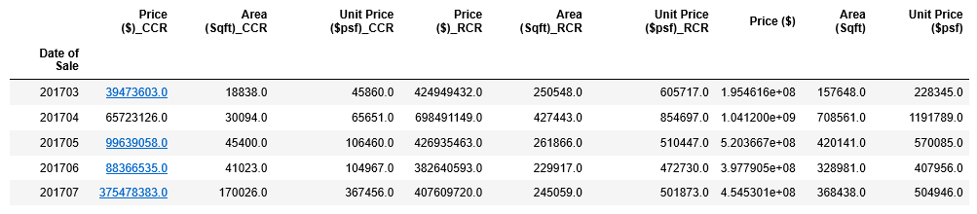

10. Mean of Unit Price of Private Property for Singapore from Mar-2017 to Mar-2020

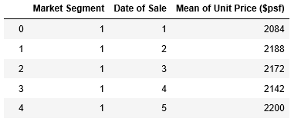

**Methodology:**

Collect the data

Explore the data

Visualize the map

Clusters in Singapore

Data pre-processing

Analysis the data

Data Visualization

**Visualize the map:**

1. The geographical visualization of the different location for Singapore

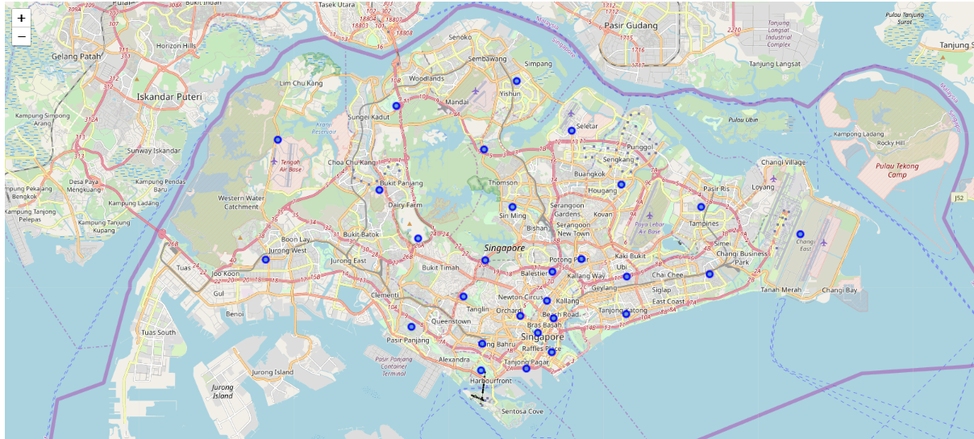

1. The geographical visualization of the different types of clusters created using K-Means for Singapore

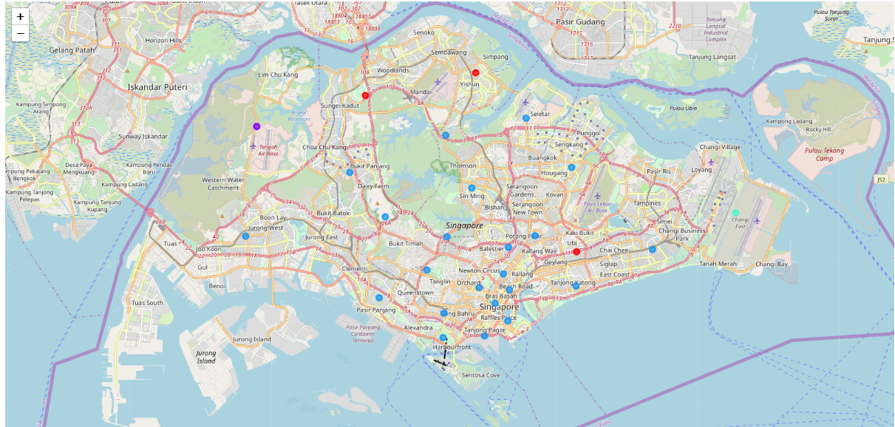

**Visualization Tools:**

1. Using Pie Graph Top Business Type Ratio for Singapore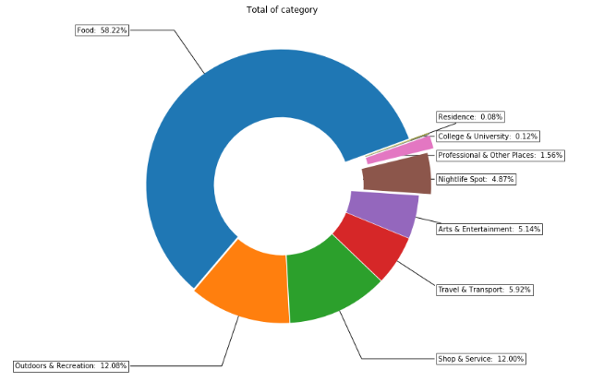
2. Using Pie Chart to Analyze Top Business Type for Every General Location in Singapore

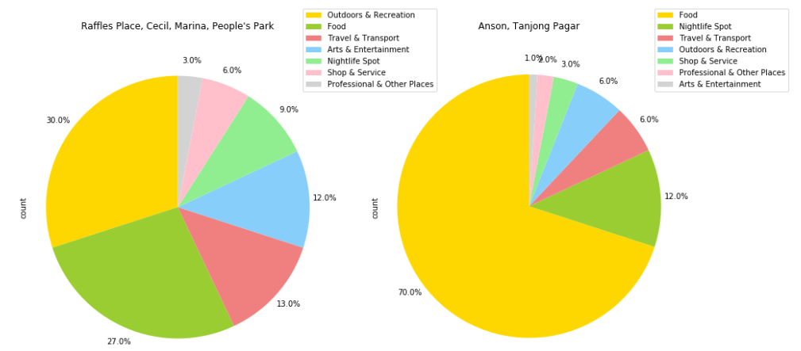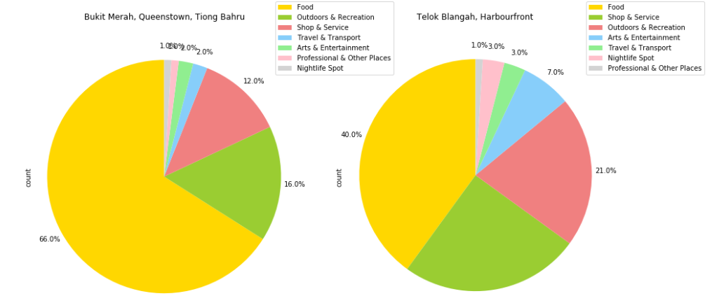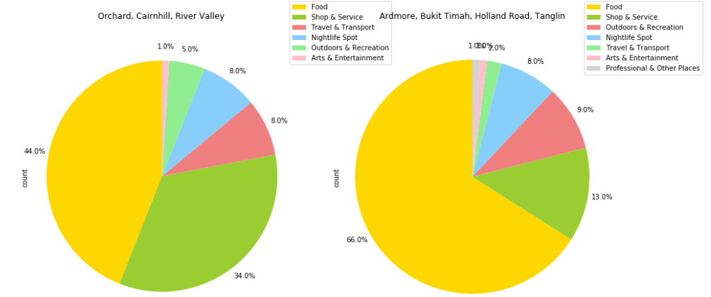

1. Using Bar Graph to Analyze Food, Outdoors & Recreation and Shop & Service for Postal District in Singapore

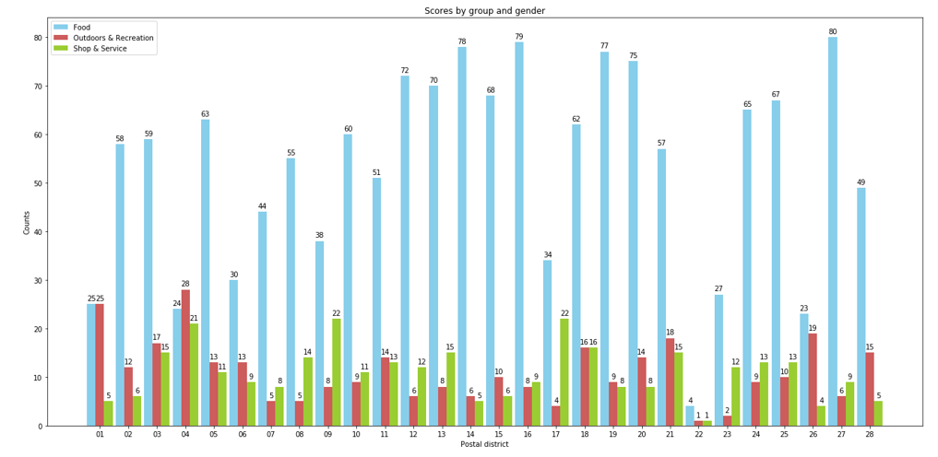

1. Using Line Chart to Analyze Private Residential Property Prices for Singapore from 1975 Q1 -- 2019 Q4

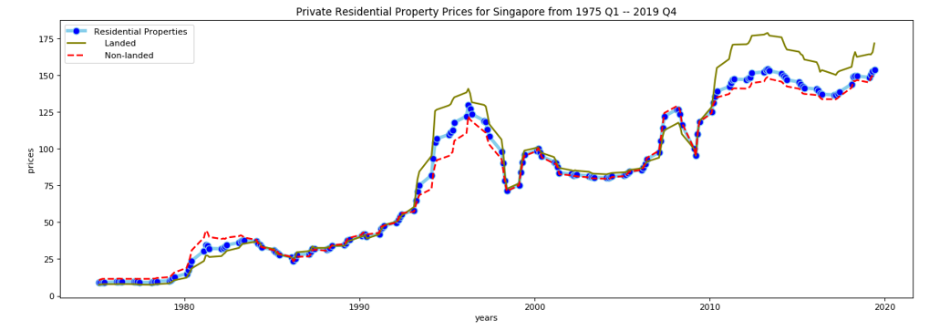

1. Using 3D Point Plot to Analyze Private Residential Property Unit Prices for Singapore

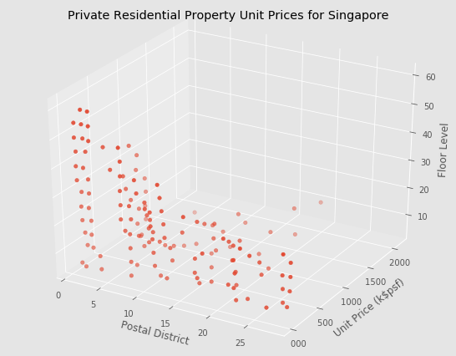

1. Using 3D Bar Analyze to Private Residential Property Sale Area for Singapore

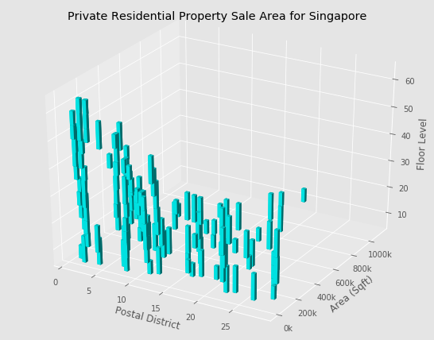

1. Using Box Plot to Analyze Private Residential Property Total Prices by Postal District for Singapore

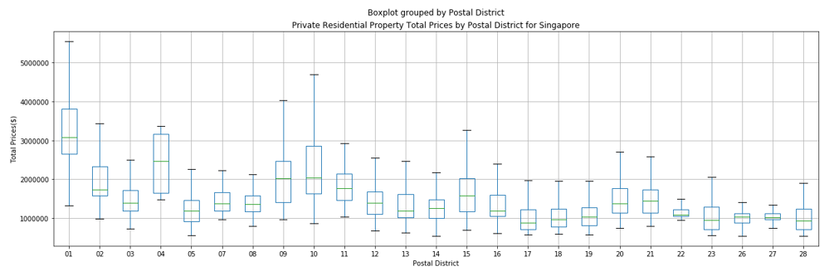

1. Using Scatter Graph to Compare Total Sale Prices of Private Property by Market Segment in Singapore from Mar-2017 to Mar-2020

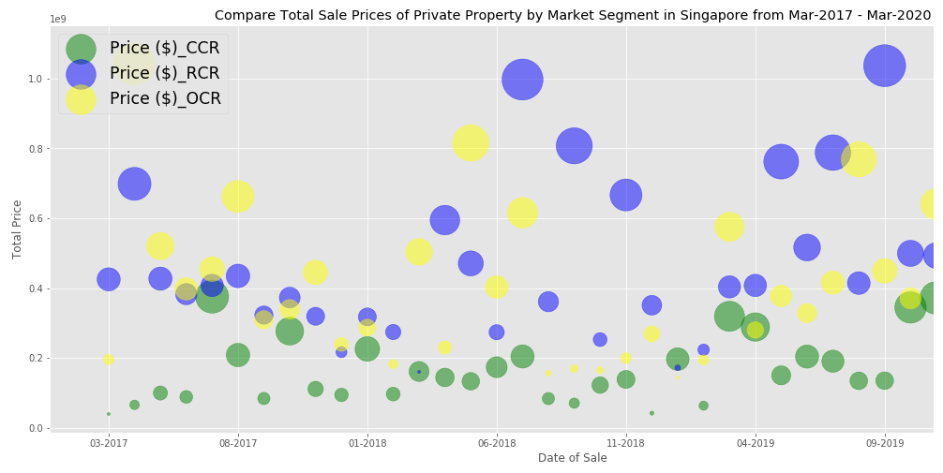

1. Using Bar Chart to Compare Total Sale Area of Private Property by Market Segment in Singapore from Mar-2017 to Mar-2020

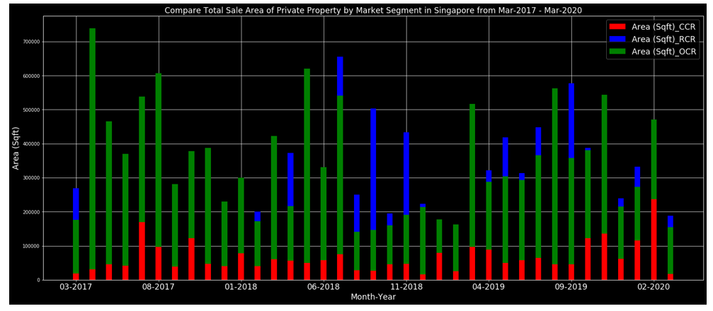

1. Using 3D Surface Plot to Analyze Mean of Unit Price of Private Property for Singapore from Mar-2017 to Mar-2020

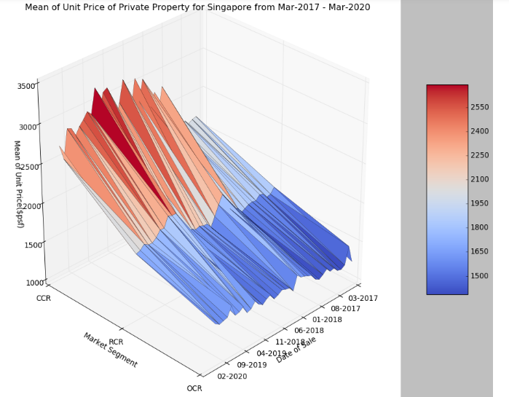

1. Using Word Cloud to Analyze Number of Private Property Project for Every Area in Singapore from Mar-2017 to Mar-2020

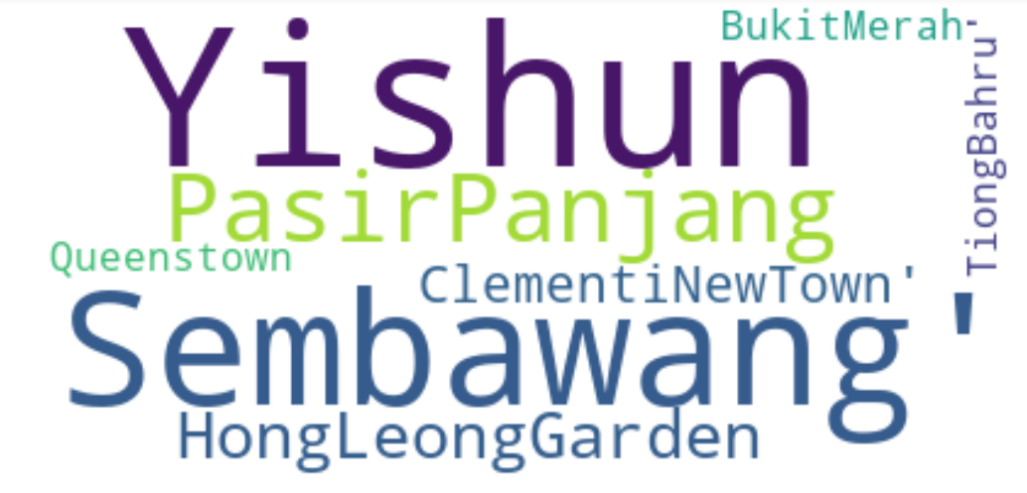

**Conclusion:**

In this project, we can discover the following opinion:

|  |  |
| --- | --- |
| 1. The most popular commercial is Food, the second one is Outdoors & Recreation, the third is Shop & Service in Singapore. But in the Post District 01(Raffles Place, Cecil, Marina, People's Park),04(Telok Blangah, Harbourfront),22(Jurong, Tuas) , Outdoors & Recreation is the most business. When people pay more attention to diet, they also pay more and more attention to outdoor & recreation activities. So I think white collar may be like these three district more. 2. Through Analysis of Private Residential Property Prices for Singapore from 1975 Q1 -- 2019 Q4, we found the Private Residential Property Prices may be higher and higher, and landed properties higher than Non-landed properties, if don’t have COVID-19. 3. From 3D Point Plot Analysis of Private Residential Property Unit Prices and 3D Bar Analyze Private Residential Property Sale Area for Singapore， we found:    1. There aren’t sale the private landed property within the last 36 months for Post District 06(High Street, Beach Road (part)),24(Lim Chu Kang, Tengah) and 25(Kranji, Woodgrove, Woodlands).    2. High-rise buildings are mainly concentrated in Post District 01(Raffles Place, Cecil, Marina, People's Park), 02(Anson, Tanjong Pagar), and 03(Bukit Merah, Queenstown, Tiong Bahru).    3. The highest unit price($psf) and the most sale area are mainly concentrated in Post District 14(Geylang, Eunos), 18(Simei, Tampines, Pasir Ris) and 19(Serangoon Garden, Hougang, Punggol). 4. By Box Plot Analyzsis of Private Residential Property Total Prices by Postal District, we discovered that The most total sale price are Post District 01(Raffles Place, Cecil, Marina, People's Park), 04(Telok Blangah, Harbourfront) and 10(Ardmore, Bukit Timah, Holland Road, Tanglin) 5. Through Scatter Graph Comparison of Total Sale Prices of Private Property by Market Segment in Singapore from Mar-2017 to Mar-2020,we saw the highest total sale price of Market Settlement is RCR, though OCR occupy the most area. But OCR has better and better selling, it was the best total sale price in 02-212. 6. From Bar Chart Comparison of Total Sale Area of Private Property by Market Segment in Singapore from Mar-2017 to Mar-2020, we knew that the most sale area alternate between RCR and OCR and sale area of CCR had high increase in 02-2012. 7. From 3D Surface Plot Analysis of Mean of Unit Price of Private Property for Singapore from Mar-2017 to Mar-2020, we found the highest Mean of Unit Price of Private Property is OCR and hit the record in 07-2019 within latest three years. 8. Through Word Cloud Analysis of Number of Private Property Project for Every Area in Singapore from Mar-2017 to Mar-2020, we knew YISHUN has the most projects. |  |

**Reference:**

1. Postal codes in Singapore ( <https://en.wikipedia.org/wiki/Postal_codes_in_Singapore>)

2. Real Residential Property Prices for Singapore (<https://fred.stlouisfed.org/series/QSGR628BIS>)

3. Private Residential Properties (<https://www.ura.gov.sg/Corporate/Property/Property-Data/Private-Residential-Properties>)